SAMPLE
Date:  Name of organisation: .........................................  Address: .........................................  Website: .........................................  Contact: Mrs. Mary Musterfrau  Email address: m.musterfrau@gmx.com  Telephone number: ……………………………...  Geographical location of the project: …. Uganda | Herschärenstrasse 89  CH-8633 Wolfhausen  Switzerland  Tel: +41 (0)79 951 19 53  kontakt@aqua-pura.ch  www.aqua-pura.ch
Locality: …. XXXXXX

Information on the planned installation

1. | Installation site (private or government hospital, private or government school, public area, other)?
 | Place of installation: | Primary school in XXXXXX  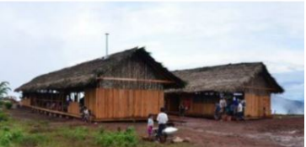
 | Project name: | St Cathryn Primary School
2. | Reasons / motivation to install a water purification system (diseases, turbidity of water, other)?
 | Reasons / motivation: | Provide children with germ-free drinking water. The water from the river is muddy and turbid. The children are often sick and then cannot go to school.
3. | Water demand?
 | Number of people to be supplied daily: | 600 pupils and villagers; total approx. 1'200 people
 | Daily demand for drinking water in l: | 6'000 l
 | Daily demand for service water in l: | Varies. Approx.10'000 l; also, for a few goats and in the dry season the gardens / fields.

4. | Existing water source (river, lake, borehole, well, public water supply, rainwater storage, other)?
 | Type of current water source: | River approx. 500 m away.
 | Amount of water available daily - rainy season: | unlimited
 | Daily available water quantity - dry season: | For 3 months little, but always enough
5. | How is water distributed today (piping and tapping points, hand sketch on one side, photos)? See also last page
 | Photograph of the current water point: | 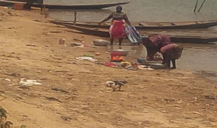  No infrastructure available. The villagers fetch the water in canisters and open containers.
6 | Pollution of the water with particles (sand, turbidity, etc.)?
 | Colour of the water (possibly a photo of a filled water bottle): | 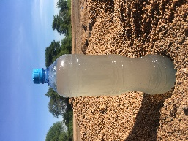  The water is murky, especially during the rainy season
 | Type of turbidity: | Sand, dirt from animals
7. | Inorganic contaminants in existing water such as lead (Pb), copper (Cu), arsenic (As) others?
 | Known contamination: | Not known. There are no mines in the area.
8. | Microbial contamination (Escherichia coli, Vibrio cholera, Salmonella, others)?
 | Known bacteria and viruses: | Not known. The inhabitants of the village, especially the children, suffer from diarrhoea very often.
9. | Access to an incubator to conduct a water test. (Hospital, doctor, other)?
 | Location of incubator: | Hospital 50 km away (approx. 2 h by Motorbike)

10. | Current availability of electricity (public supply, local solar, none)?
 | Type of electricity supply: | No electricity available.
 | Voltage in V: | n/a
 | Reliability/ frequency of interruptions: | n/a
11. | Responsible person and contact person to the aqua pura team (telephone numbers / e-mail address)?
 | Project Manager Installation: | Member of our organisation, Mr. YYYY
 | Responsible for on-site operation: | Caretaker of the school, Mr. XXX
12. | Possible contribution / involvement of beneficiaries?
 | During installation: | Installation of the necessary pipelines with the help of the villagers
 | For maintenance: | Monitoring of the system performance and cleaning of the filters under the guidance of the caretaker
13. | Are there other NGOs involved in the clean water project?
 | Name of NGO: | NGO XYZ
 | Type of involvement: | Donation of a solar system for the school
14. | Possible date for the installation work?
 | Start of installation work: | If possible, start in January 202X when our employee will be in XXX for 2 months.
 | Start of use: | Mid-March 202X at the latest, before our employee goes back.

15. | Are other installation materials required for the operation of the drinking water treatment plant (valves, pipes, pumps, tank, etc.)?
 | Materials required: | Approx. 500 m pipeline from the dam to the school, 4 water taps. 1 water tank - X (?) l.
15. | Open questions from your side to aqua pura?
 | Open questions: | - How is the material transported to XXXX?  - How long does a UVC tube last?  - How is the system cleaned?  - Is there instruction on site?

Signature of the applicant:

Appendix

Re 5: | How is water distributed today (piping and tapping points, hand sketch / plan on one side, photos)?

X m
Y m
ca. 500 m to the river
ca. 20 m
difference in altitude
river
Building 1
Building 2
ca. XX m to the nearest huts of the village
sand

